**Git and Github**

1. **Configure Git using git config command**

you can set various settings such as your username, email, default text editor

Git config --global user.name “rushikesh”

Git config --global user.email [rushikeshja@cybage.com](mailto:rushikeshja@cybage.com)

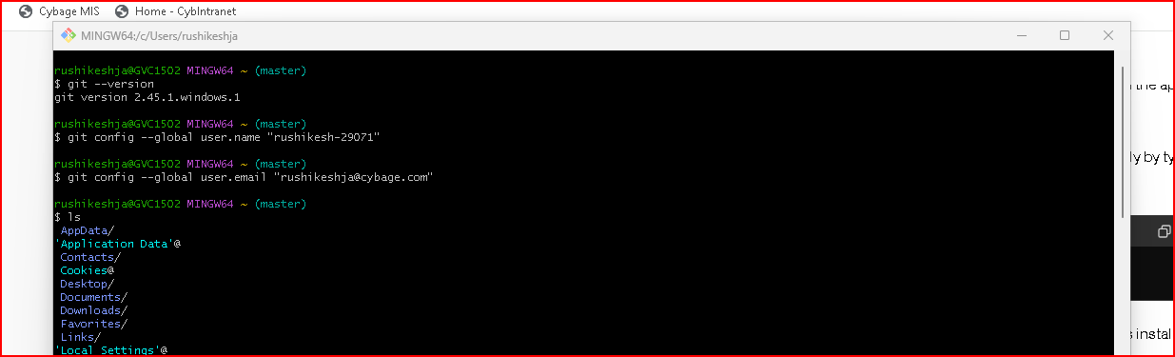

1. **Create a repo on GitHub, naming convention should be <rushikesh-29071>**

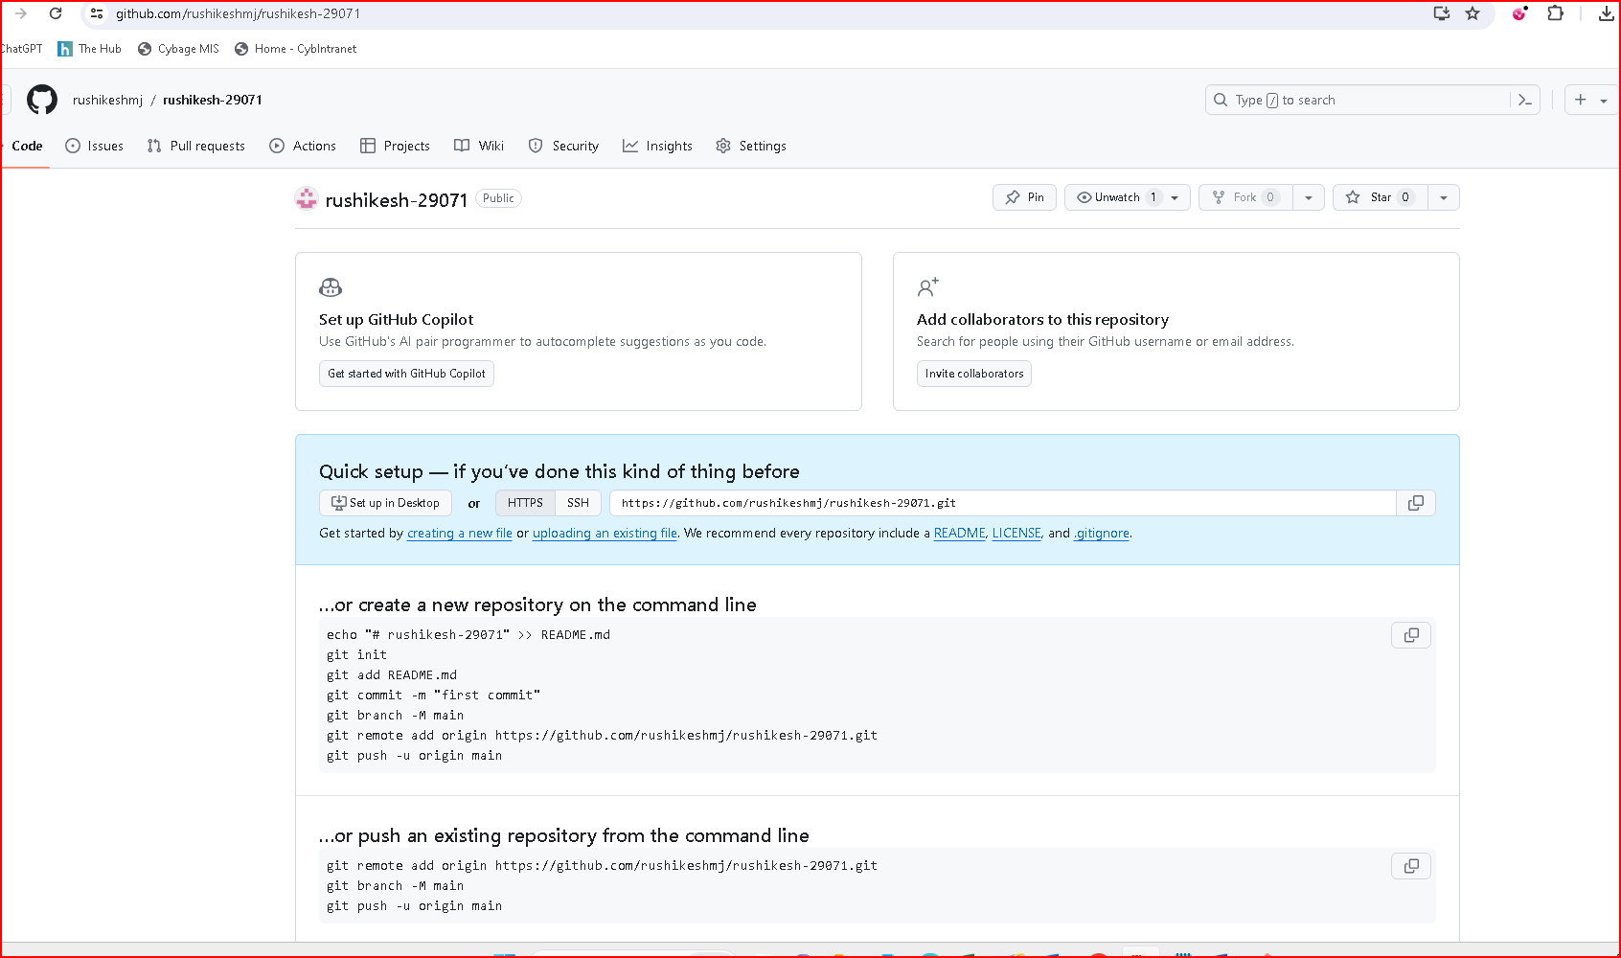

1. **Clone the repo in local machine**

to create a copy of an existing Git repository onto your local machine

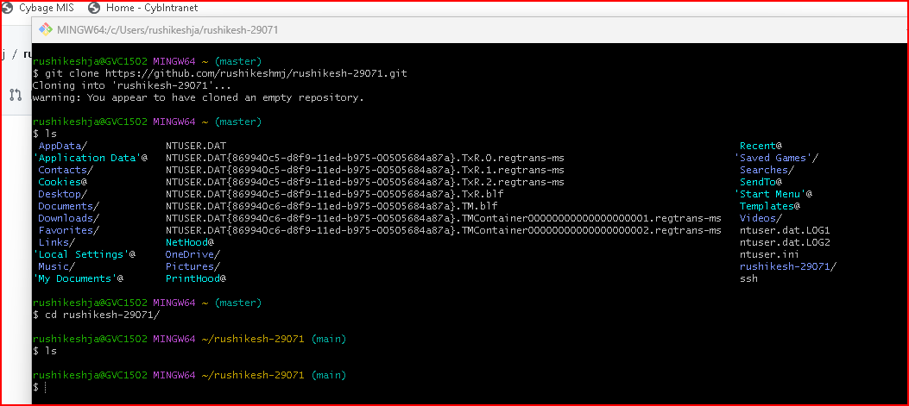

1. **Create a text file in that folder using git CLI**

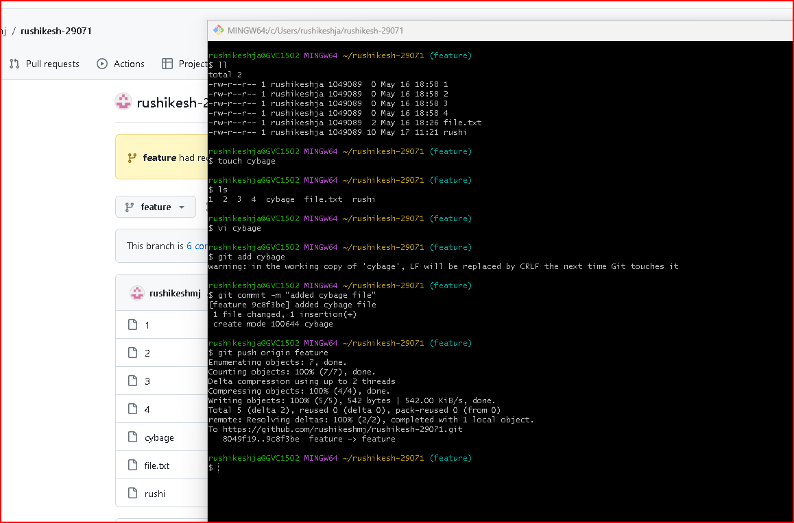

1. **Use git status command for showcasing the status of staging area and git repository**

used to display the current state of the working directory and the staging area in relation to the Git repository

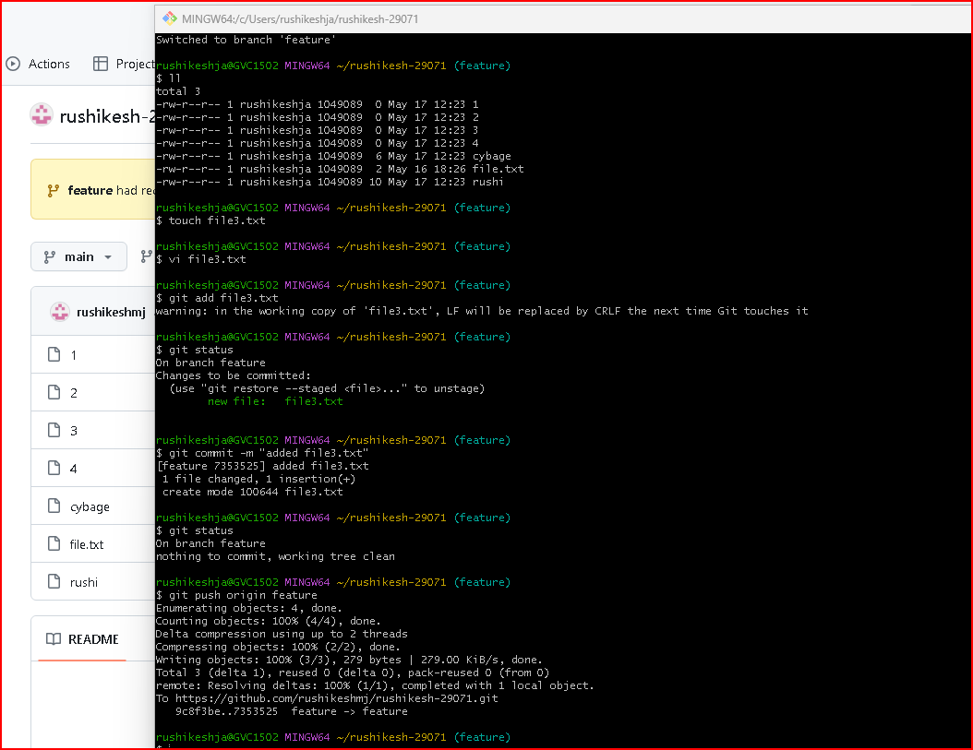

1. **Try to add & commit the changes**

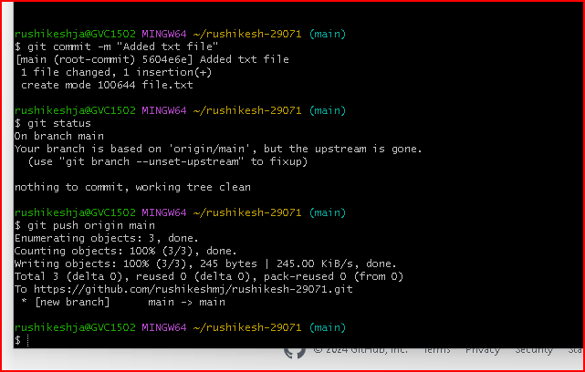

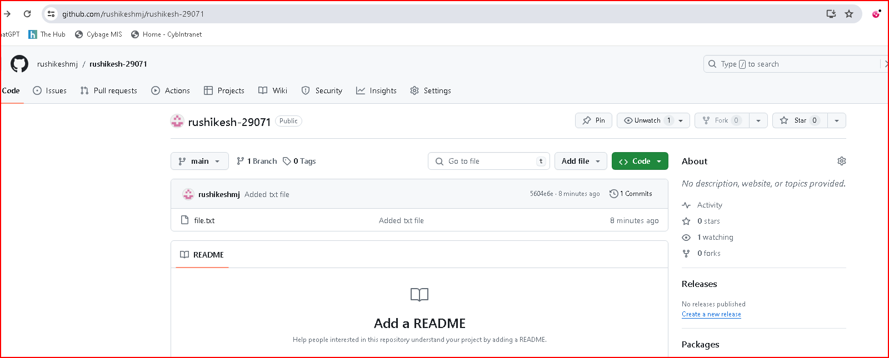

1. **Create new repo and initialize it on local machine and add git URL as an alias in local machine**



1. **Push the code on main branch**

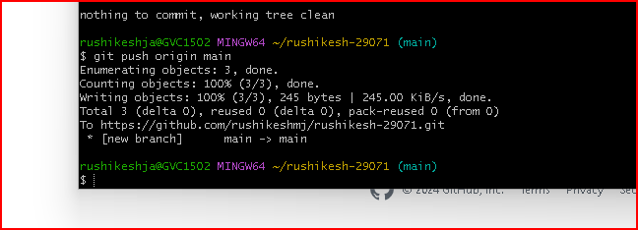

1. **Create feature branch and add new text file on feature branch (apply branch protection rule on main**

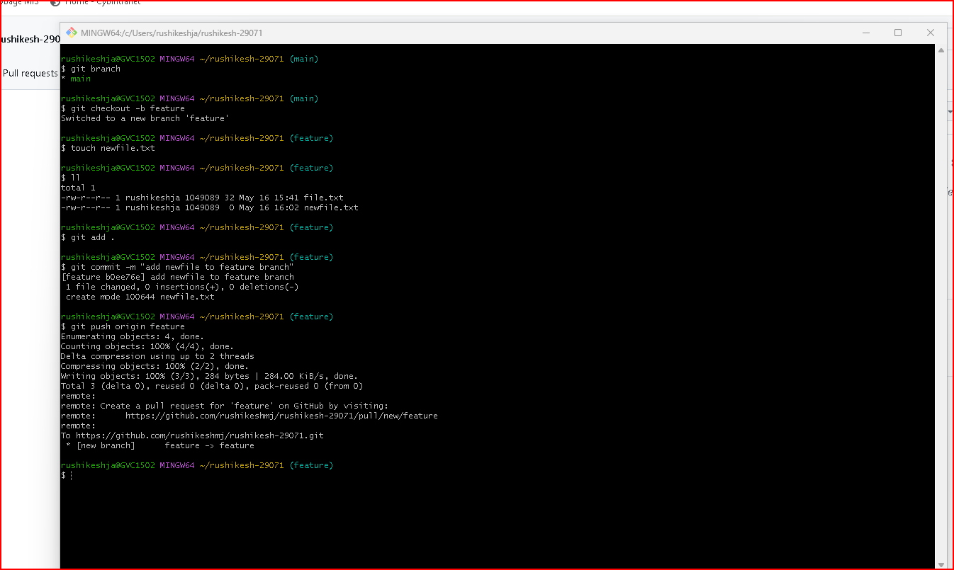

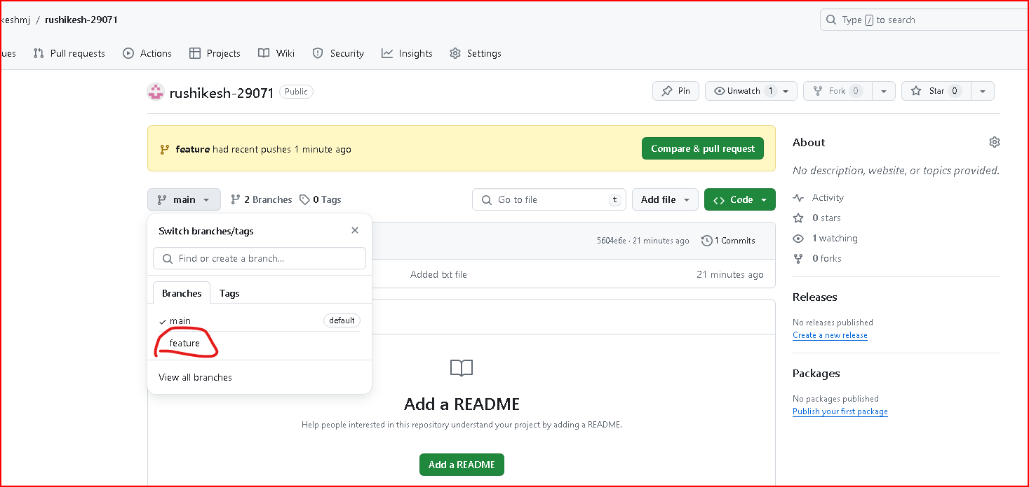

1. **Use diff command to showcase the difference between 2 branches**

used to show changes between commits, commit and working tree

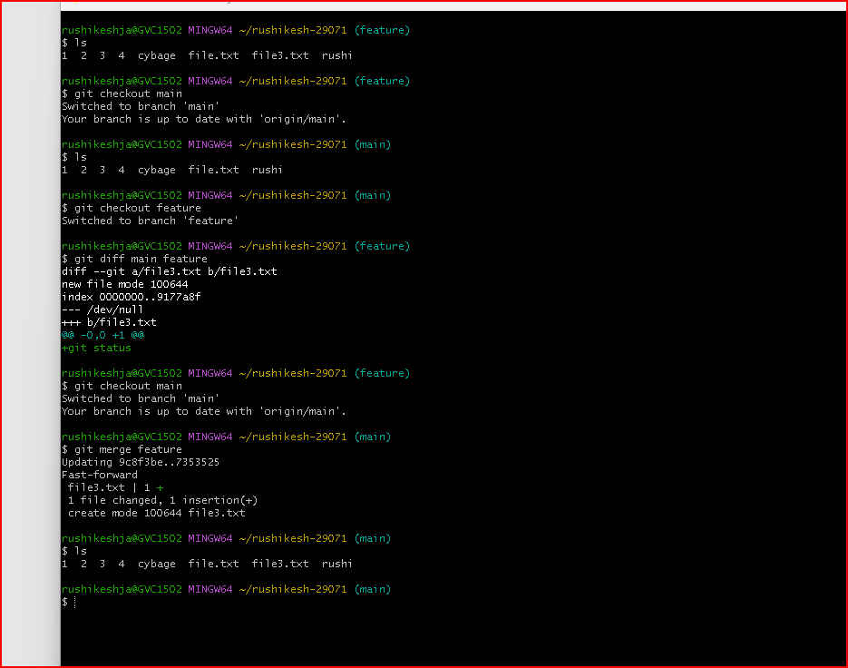

1. **Create pull request to merge 2 branches and try with other way from git CLI using git merge(both should be used)**

used to propose changes to a repository hosted on a platform like GitHub

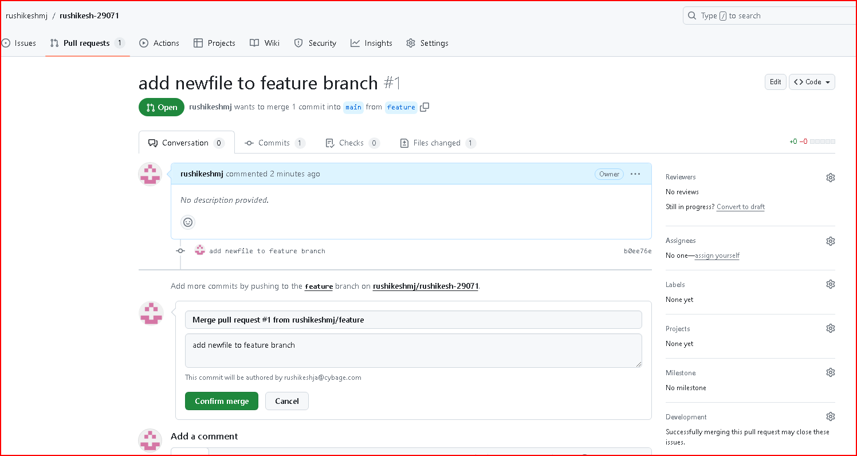

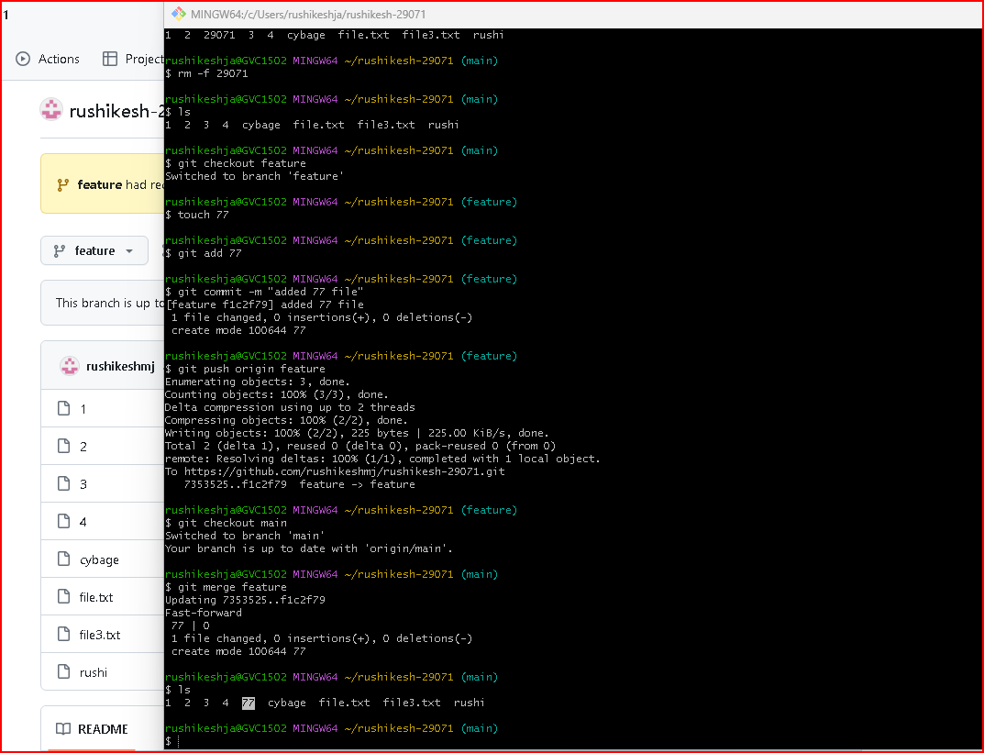

1. **Use git pull command to fetch the repo and download content from a remote repo and update the local repo to match the content**

used to fetch and integrate changes from a remote repository into your current branch

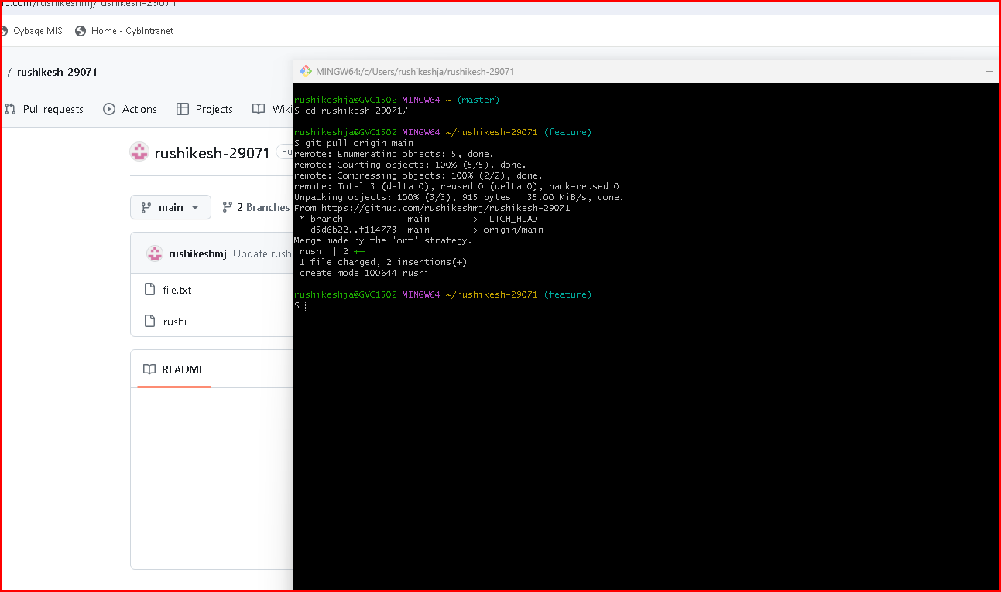

1. **Create 4-5 commits and use reset command to go on 2nd commit**

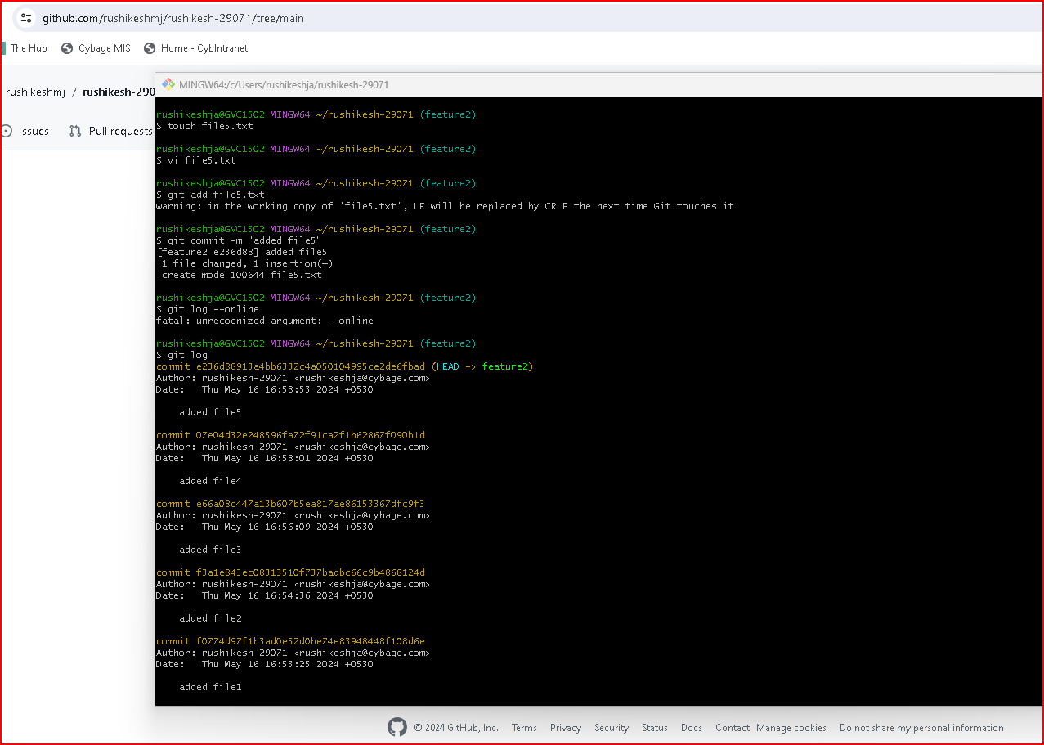

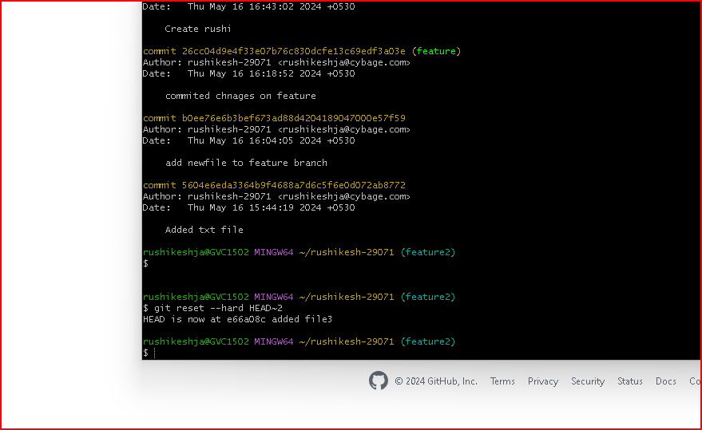

1. **Fork the provided repo -** [**https://github.com/Sakshibhu/localRepo**](https://github.com/Sakshibhu/localRepo)

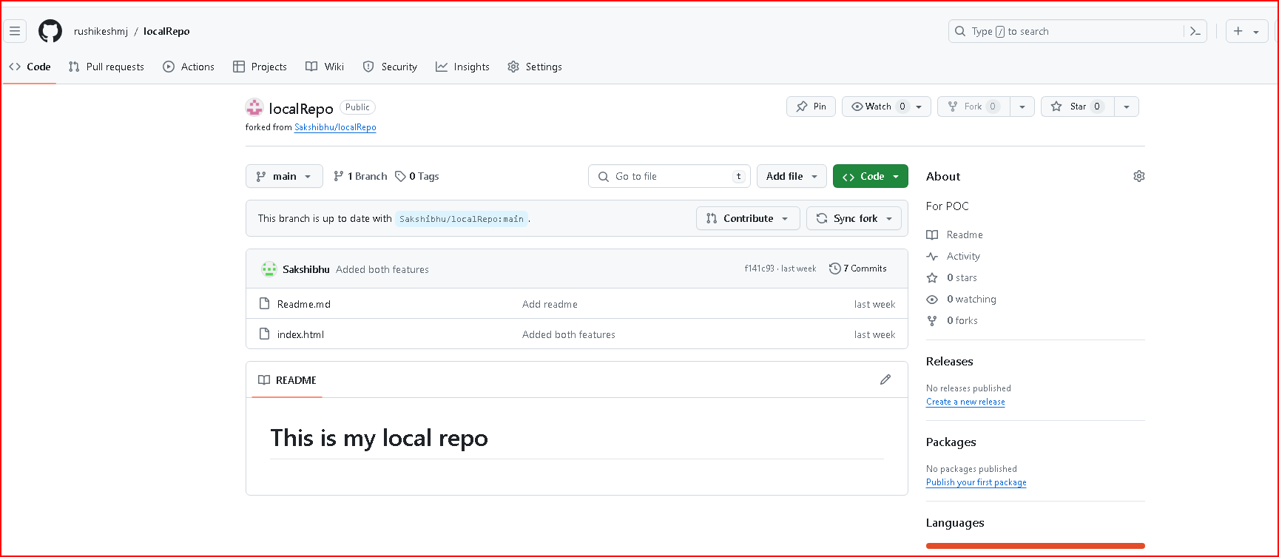

1. **Create PAT token with 30 days expiration date**

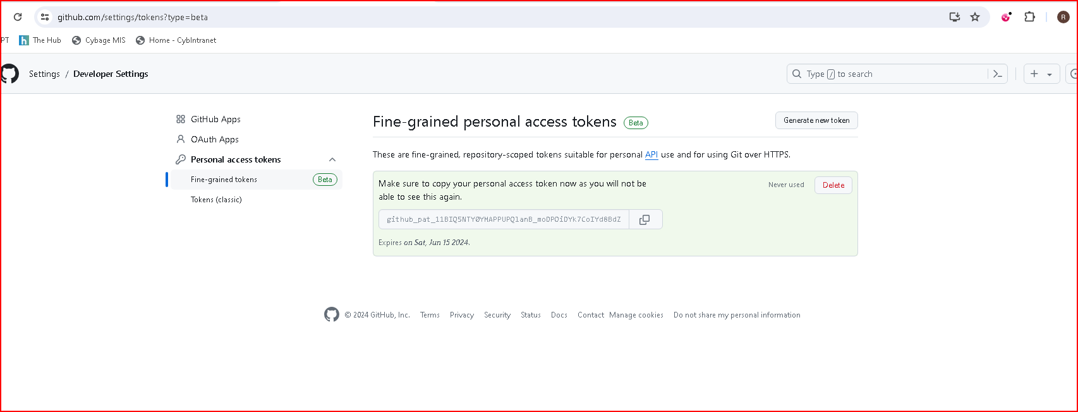

**Git revert** - used to undo changes made in a previous commit by creating a new commit that undoes those changes

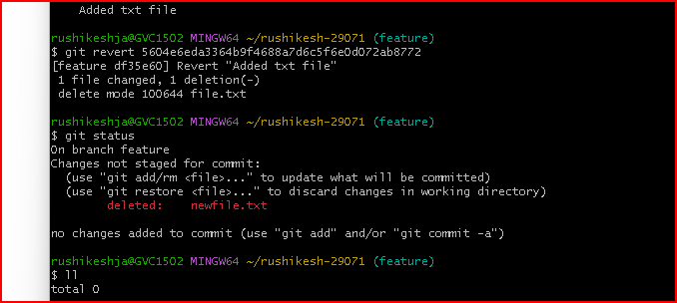

**Git cherry-pick** - used to apply a specific commit from one branch onto another branch

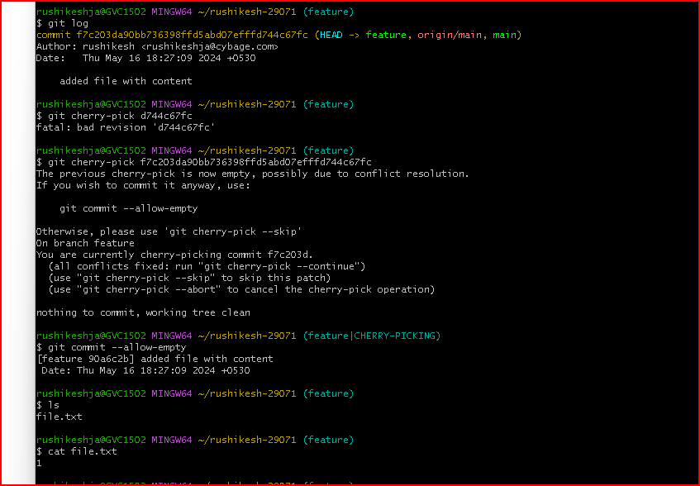

**Git rebase -** used to integrate changes from one branch onto another by reapplying each commit on top of the target branch

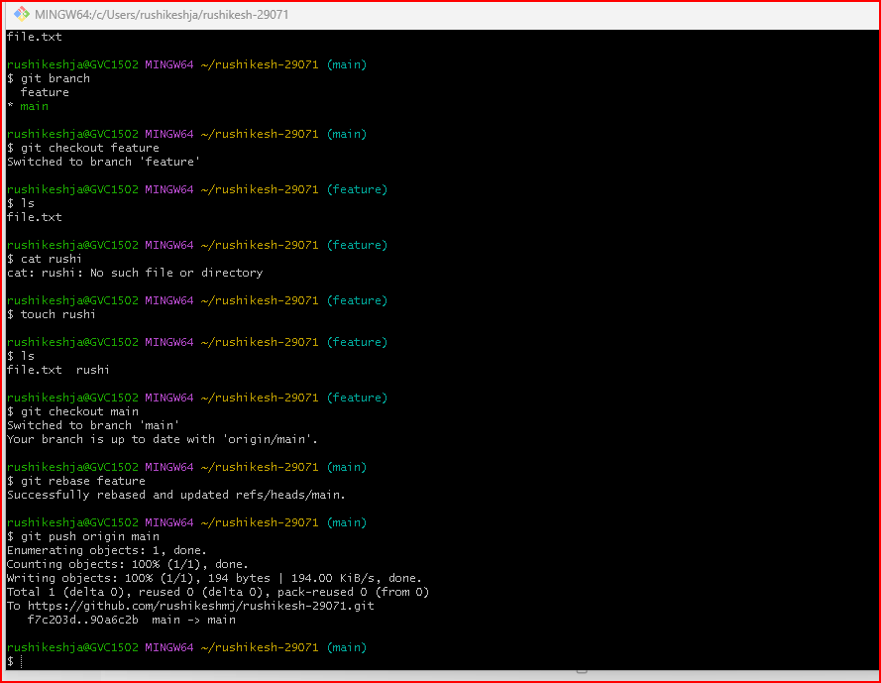

**git stash** - used to temporarily store changes in your working directory and staging area so that you can work on something else, switch branches, or perform other operations without committing the changes

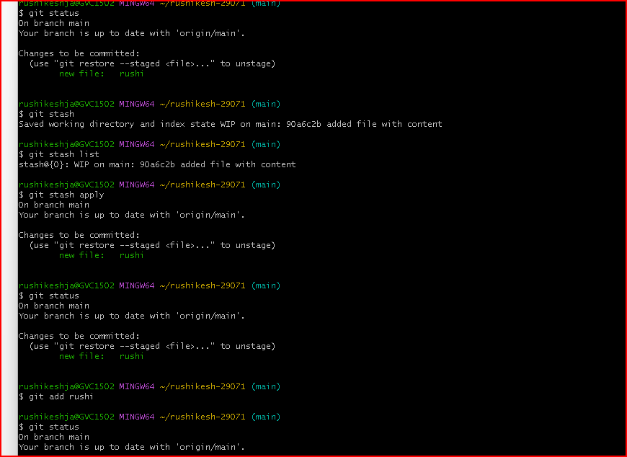

**Git sqash** - squashing commits involves combining multiple commits into a single commit

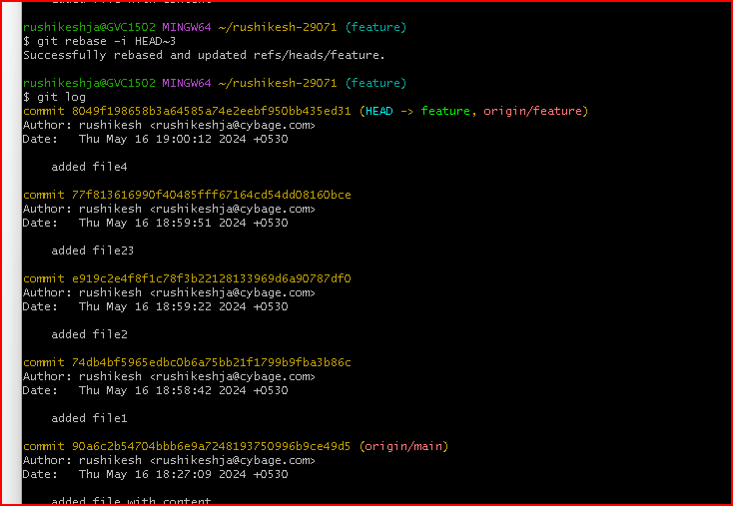

**git log:** Show the commit history, including commit messages, authors, and dates

